Early Start
Therapist Reporting Guide

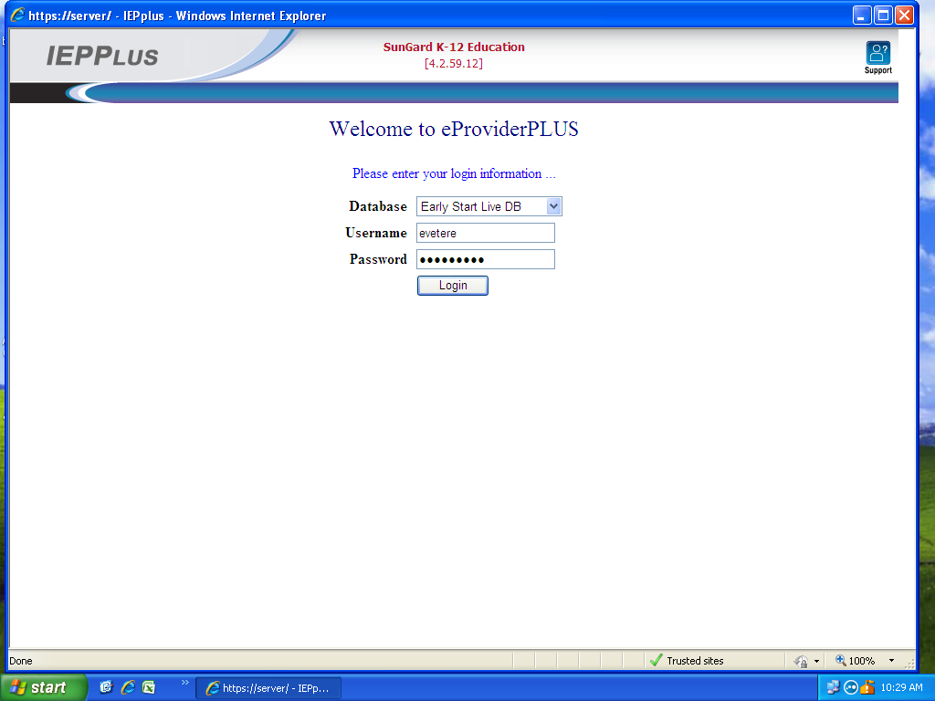

Sungard (IEPPlus) Link for Billing/Reporting: https://eschool.earlystartinc.com

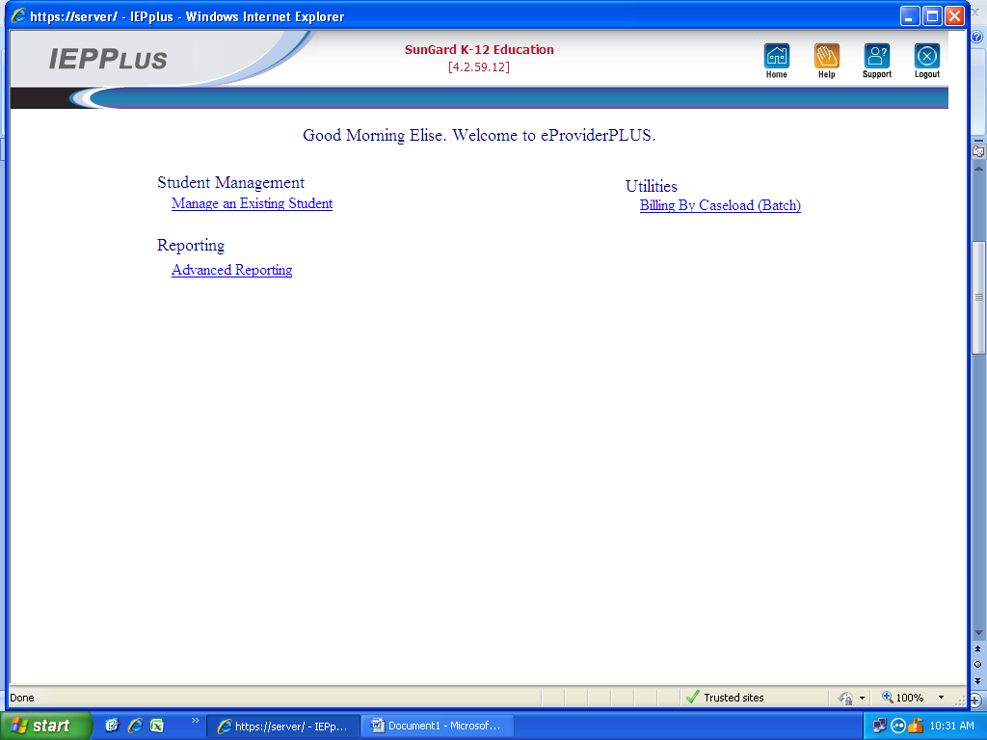
Select: Advanced Reporting

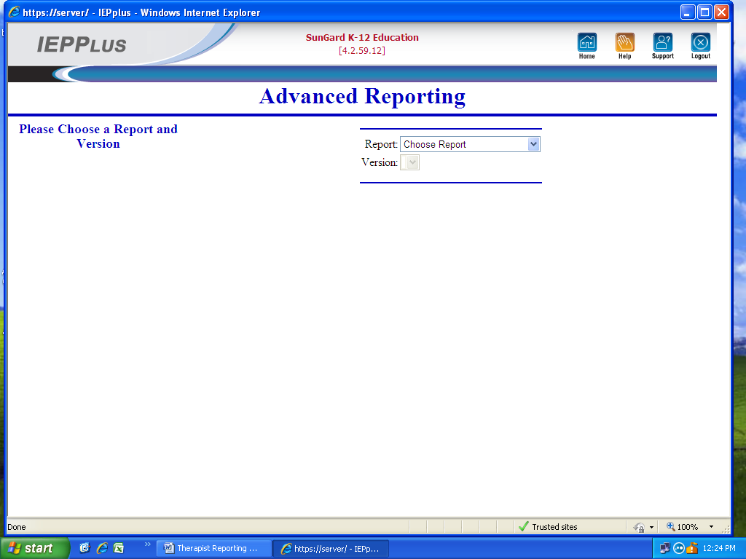
Report: Attendance
Version: Standard
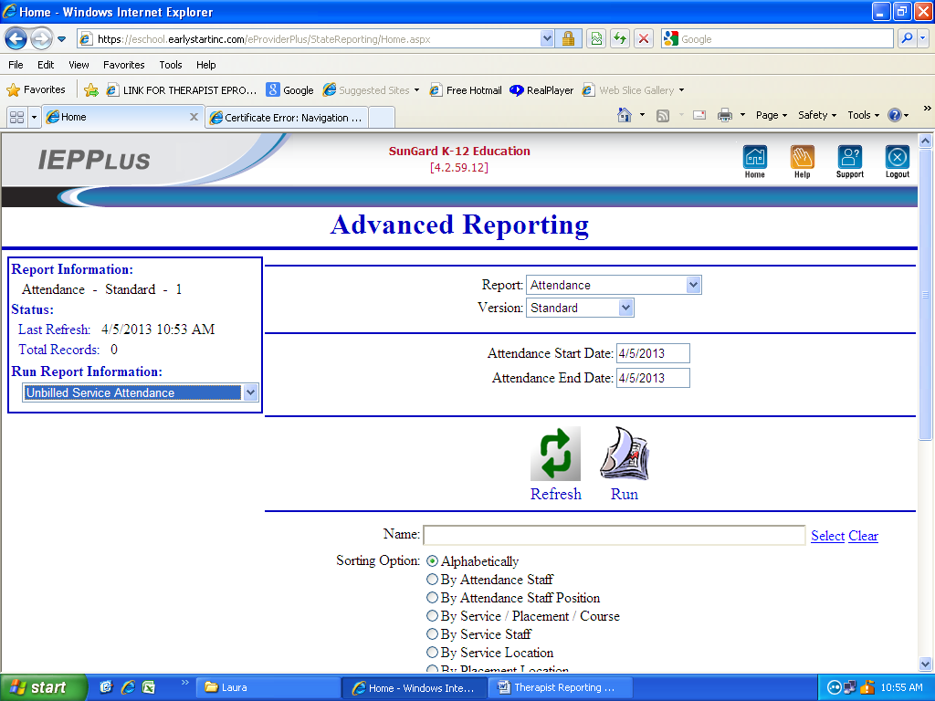
Run Report Information: Unbilled Service Attendance.
Attendance Start Date: First day entered.
Attendance End Date: Last day entered.
Attendance Reason: Choose *Provided , then Print. Repeat process if Team meeting, and need to choose * Provided Co-Visit, then Print. Only use first three choices, *Not Provided, *Provided, *Provided Co-Visit.
Attendance Staff: Select Search
In smaller box, type in last name. Click Enter, Select your name.
Select Refresh, Select Run.
Immediately print Unbilled Service Attendance Report and fax or scan this Report and Session notes immediately after billing to prevent delay in payment to you.

