Early Start
Therapist Billing Guide

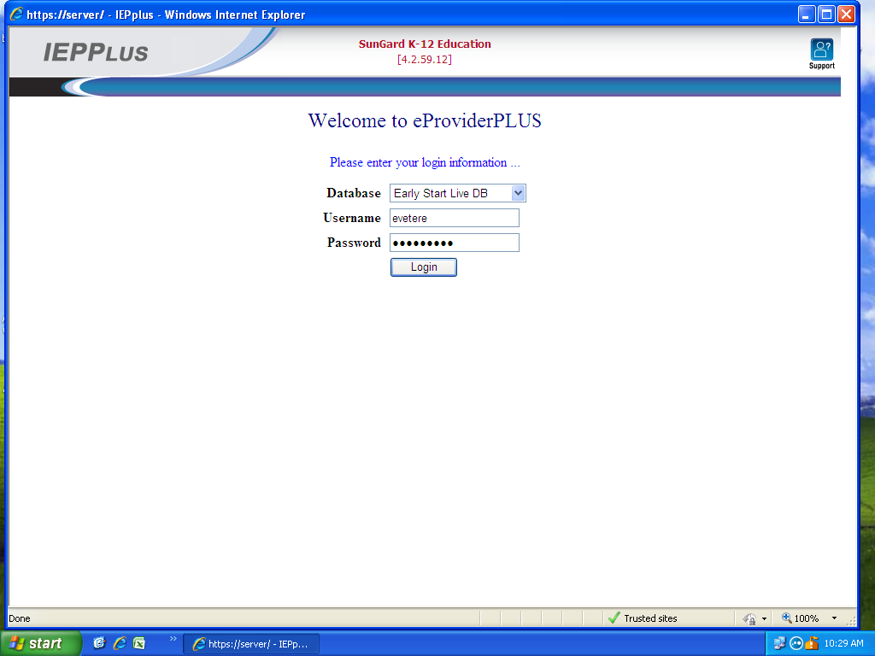

In this document, whatever is highlighted in yellow is required.

Sungard (IEPPlus) Link for Billing/Reporting: https://eschool.earlystartinc.com

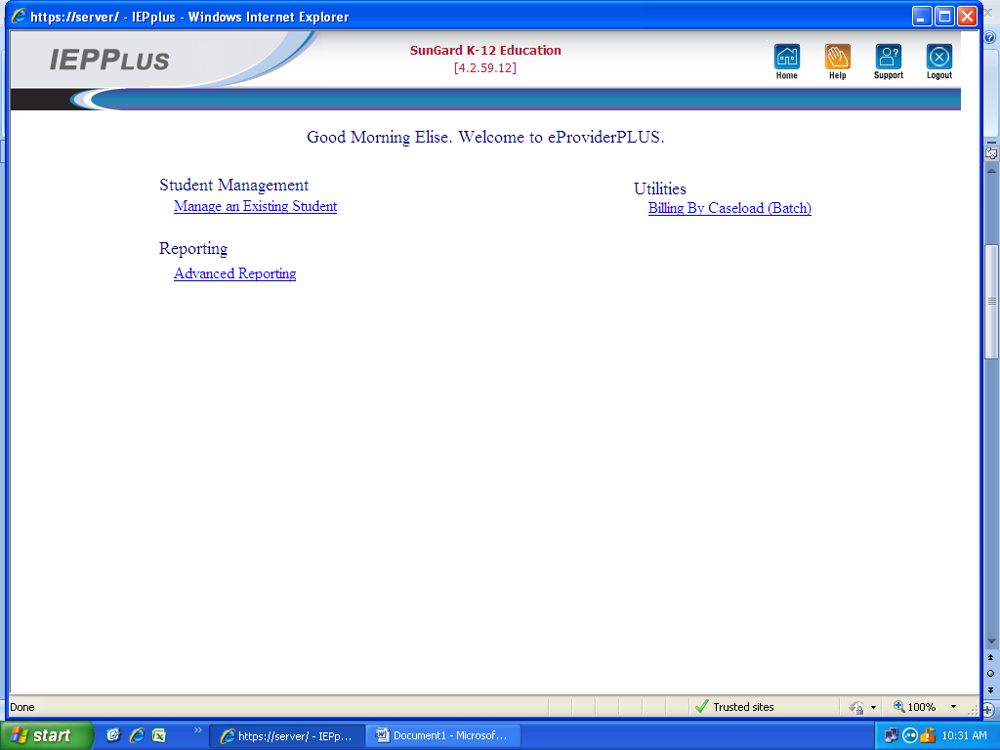
Select: Billing by Caseload (Batch)
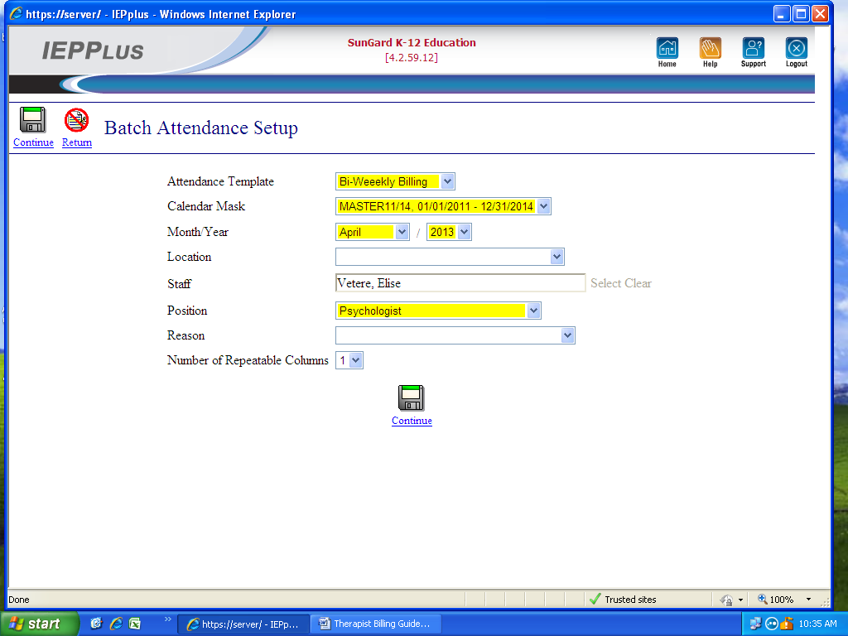

Month/Year (Make sure month reflects what you are billing).
Location and Reason remain blank.
Continue

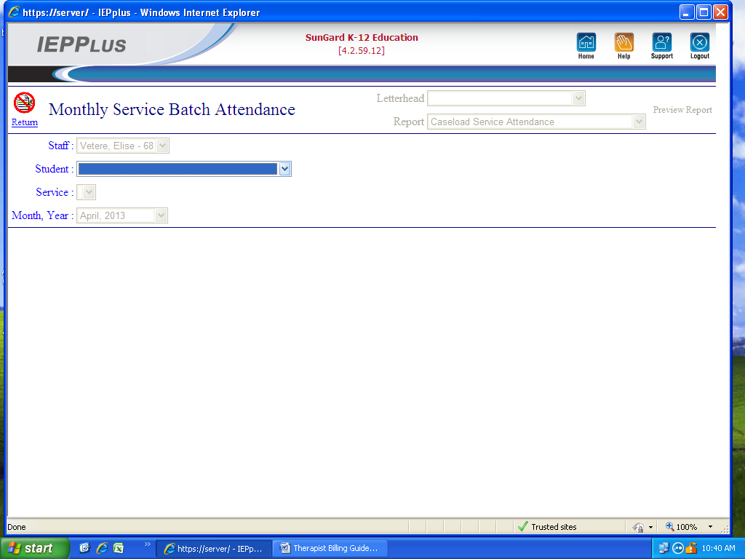

Student: Select Student from drop down menu.

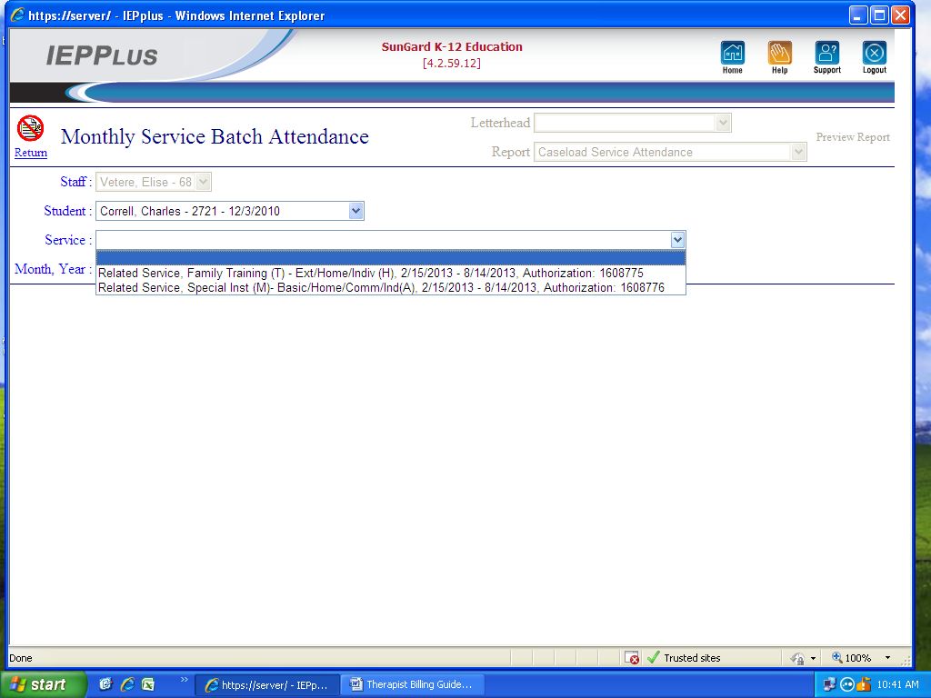
Service: Select Correct Service and IFSP Period.

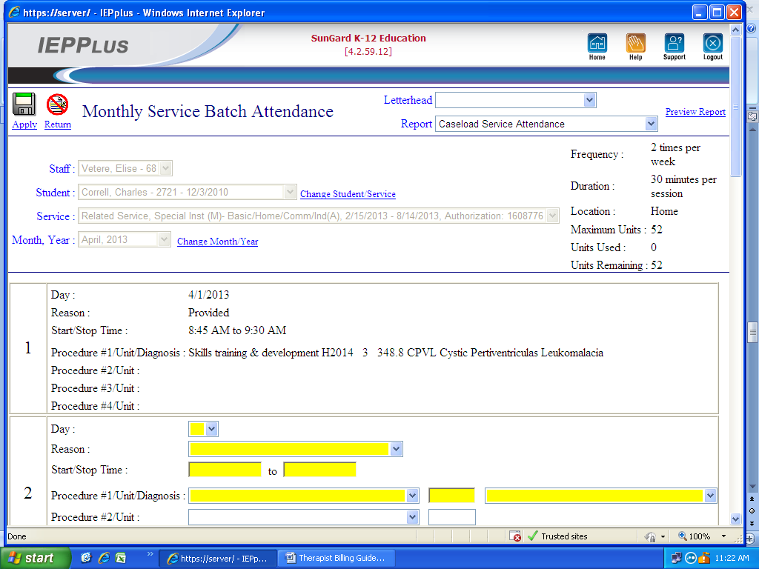
Select Change Student/Service if you need to change service for same child or select a different student, click on appropriate drop down.
Month, Year: Select Change Month /Year , (after Service is chosen, the Month Year will be highlighted, then you can change it).
If there is more than one line for Service, you need to open line to determine frequency and only bill allowed frequency for that billing week.
Day: Days of the month up to current day. Cannot future bill.
Reason: Only use Not provided (must enter time of missed session), Provided (Therapy session or Weekly Family Training), Provided- Co-Visit (Team Meetings only).
Start/Stop Time: Must use AM and PM. ie 9:00AM to 10:00AM.
Procedure #1/Unit/Diagnosis: CPT – Procedure Code / Units reflect the number of 15 minute increments used / ICD9 Code- Diagnosis, refer to previous billing for correct code.
***Example enclosed in Day 1 above.

Please Note:
Therapists cannot bill for make-up sessions themselves . Therapists cannot bill for anyone else even if session done for another therapist. Contact office if assistance needed for these scenarios.
Click on Apply after you complete and review all sessions.
If Billing record needs to be edited after Apply is selected, you must call the office to make the edit.
Immediately after entering sessions, print Unbilled Service Attendance Report.
Must Immediately fax or scan Unbilled Service Attendance Report and Session notes to office to prevent delay in payment to you.

